MikroTik Dual WAN Policy Routing and Failover Configuration
Objective
Create a configuration where:
- PC1 uses ISP1 as the primary gateway
- PC2 uses ISP2 as the primary gateway
- If one ISP fails, traffic automatically switches to the backup ISP (failover)
Topology
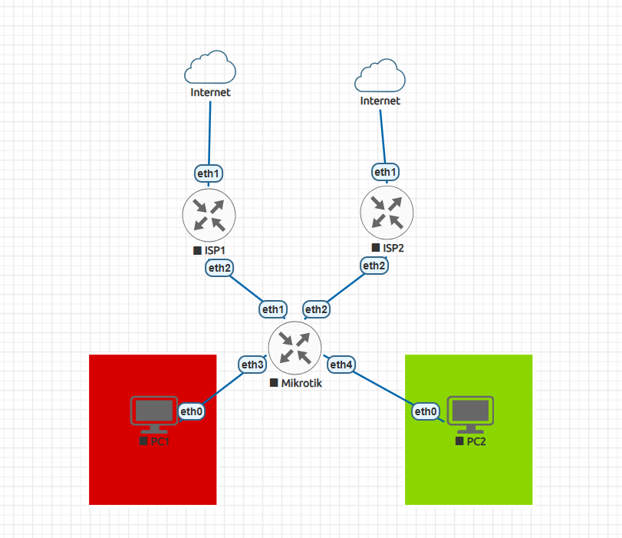
IP Address Configuration
ISP 1 | ISP2 | Mikrotik | PC1 | PC2
Ether 1  192.168.133.103/24 | Ether 1  192.168.133.103 | Ether 1  10.1.1.2/30 | Ether 1  192.168.1.254/24 | Ether 1  192.168.12.254/24
Ether 2  10.1.1.1/30 | Ether 2  10.2.2.1/30 | Ether 2  10.2.2.2/30
Ether 3
192.168.11.1/24
Ether 4
192.168.12.1/24

Configure ISP 1 and ISP 2 : IP Address, DHCP Server, NAT
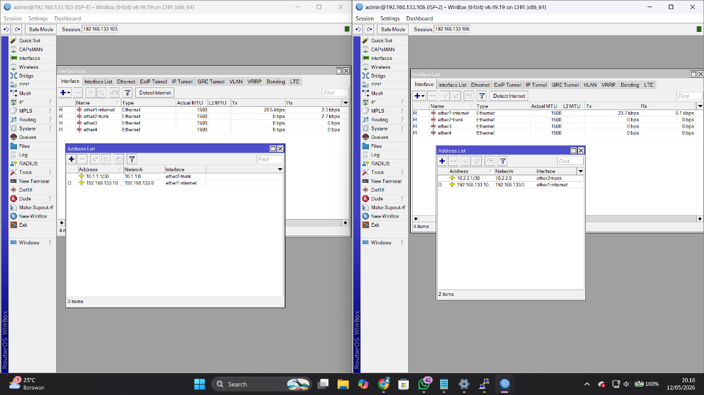
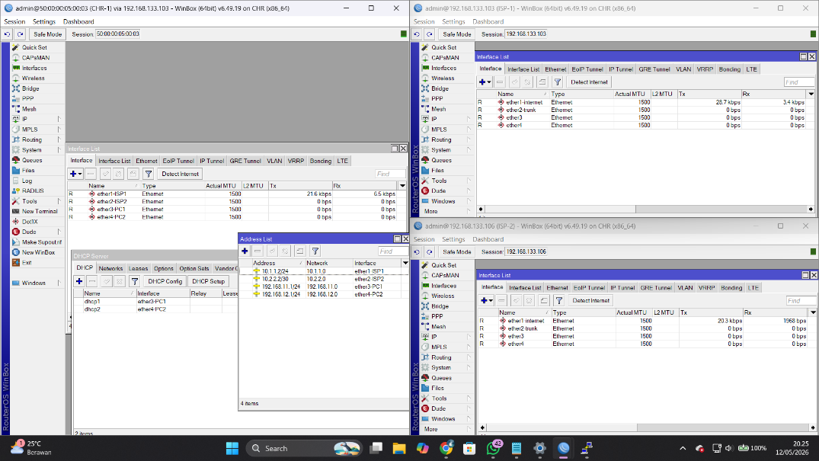
Configure Mikrotik IP Address, DHCP Server, NAT

Add Mangle rule to filter route every PC
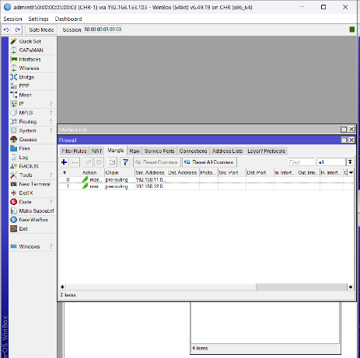
/ip firewall mangle
add chain=prerouting src-address=192.168.10.0/24 action=mark-routing new-routing-mark=toISP1
add chain=prerouting src-address=192.168.20.0/24 action=mark-routing new-routing-mark=toISP2

Explanation
Mangle rules are used to mark packets based on source IP address.
- Network 192.168.10.0/24 receives the mark toISP1
- Network 192.168.20.0/24 receives the mark toISP2
The routing mark allows the router to select different gateways for different clients.
Configure Route and Failover
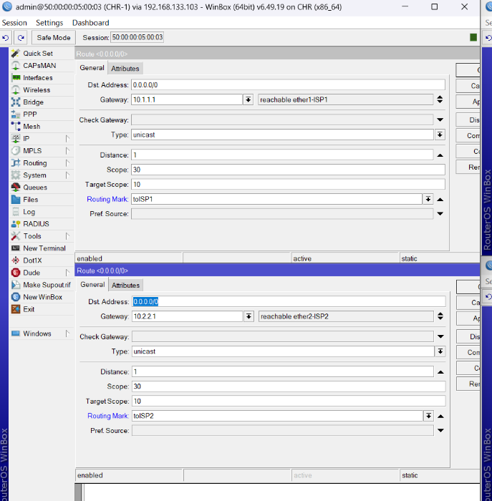
/ip route
PC1 Primary :
add dst-address=0.0.0.0/0 gateway=10.10.10.254 routing-mark=toISP1 distance=1 check-gateway=ping
PC1 Backup :
add dst-address=0.0.0.0/0 gateway=20.20.20.254 routing-mark=toISP1 distance=2
PC2 Primary : add dst-address=0.0.0.0/0 gateway=20.20.20.254 routing-mark=toISP2 distance=1 check-gateway=ping
PC2 Backup : add dst-address=0.0.0.0/0 gateway=10.10.10.254 routing-mark=toISP2 distance=2
Routing Explanation
Distance
Distance is used to setting route priority.
- distance=1 → primary route
- distance=2 → backup route
The router always chooses the route with the lowest distance value.

Check Gateway
check-gateway=ping
This feature checks whether the primary gateway is still reachable.
If the gateway does not respond :
- the route becomes inactive
- the router automatically switches to the backup route

Testing
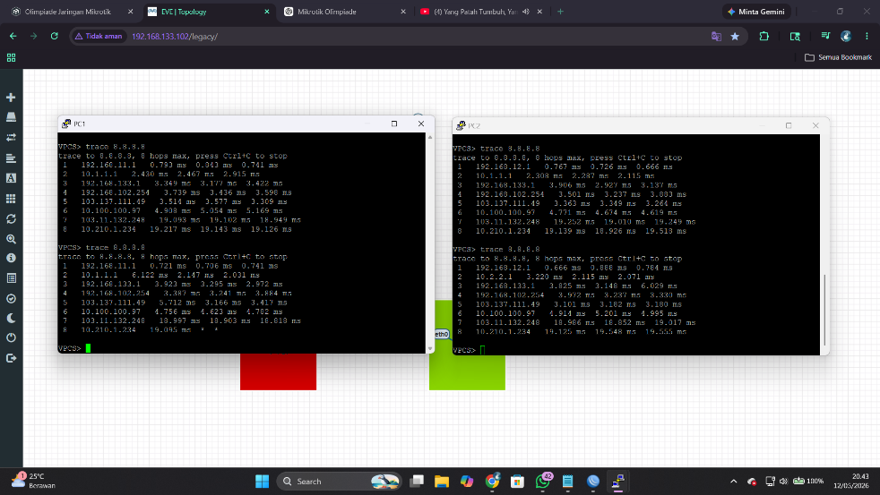
We can see in the photo PC1 access internet from ISP1 and PC2 from ISP2, if the ISP1 trouble or have an problem PC1 will access internet from ISP2 so on.
Test if connection from ISP1 trouble :
